**Introduction to the program**

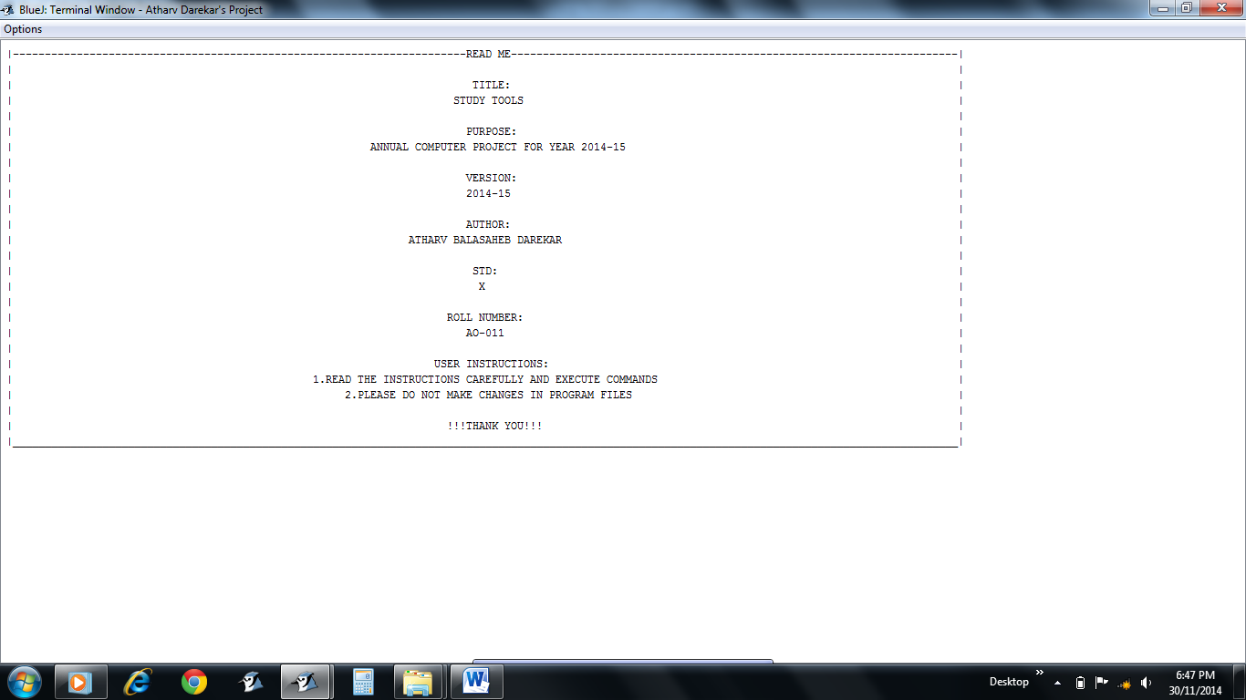

* Read Me / Introduction of the **Study Tools**

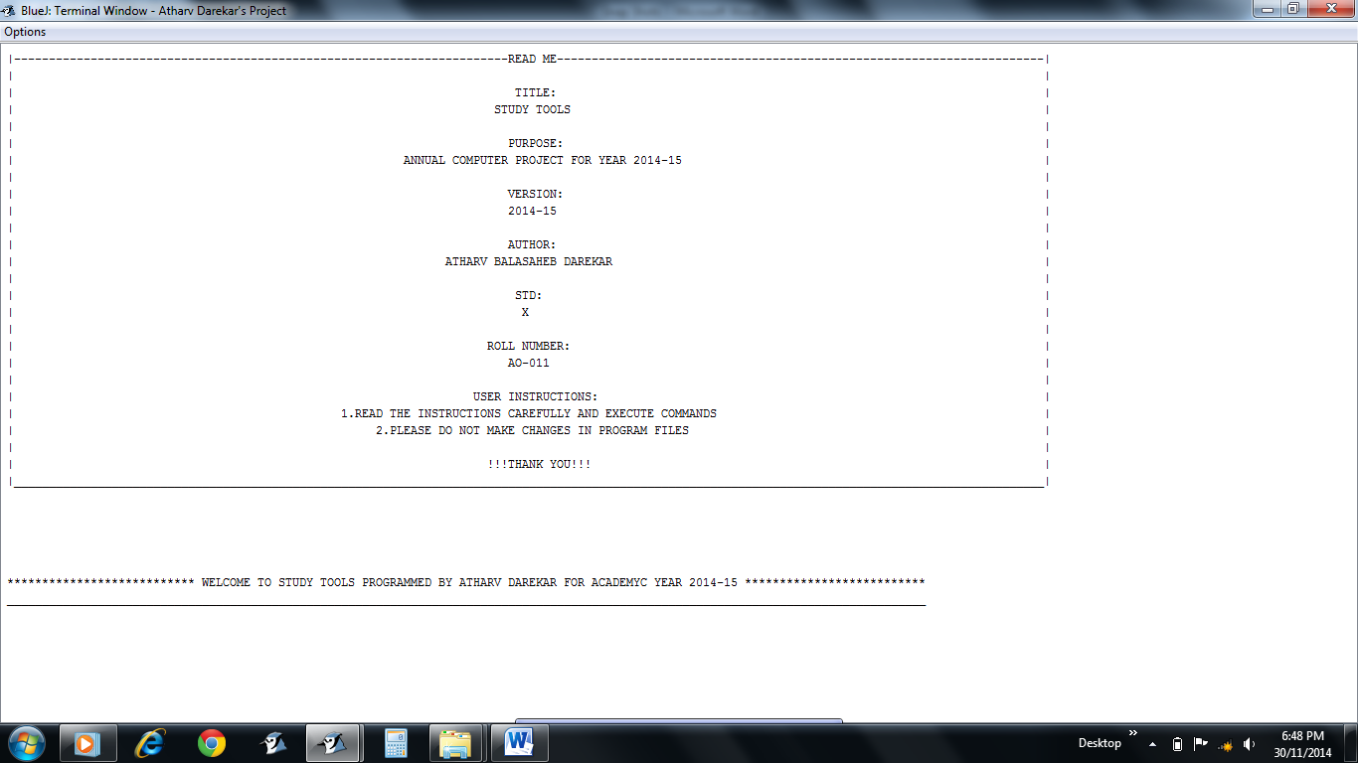

* Greeting Message

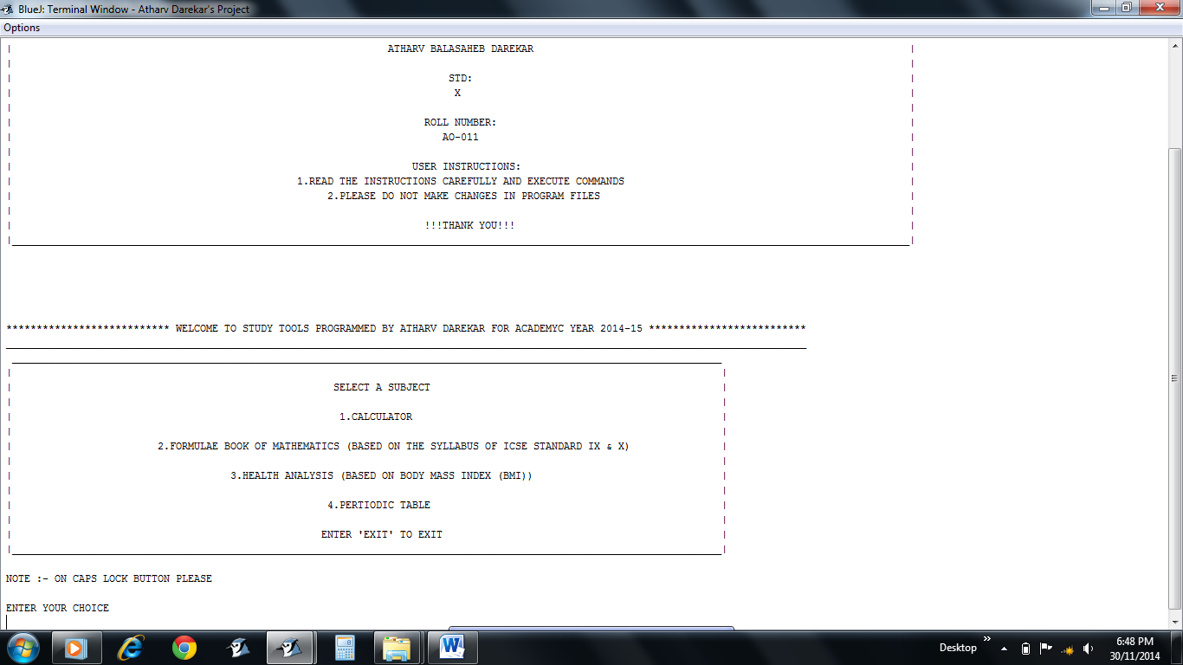

* Main Menu
* Read the instruction given “NOTE :- ON CAPS LOCK BUTTON PLEASE” and follow it

**CALCULATOR**

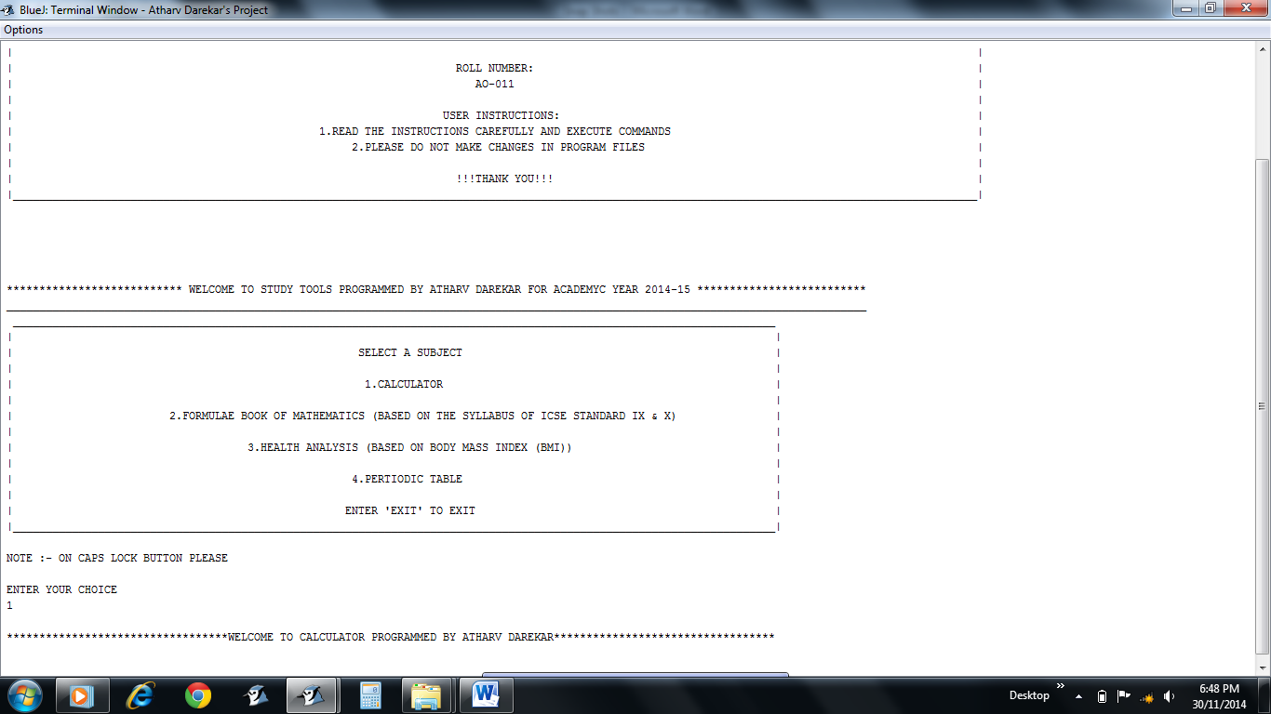

* 1 option for CALCULATOR
* Greeting Message

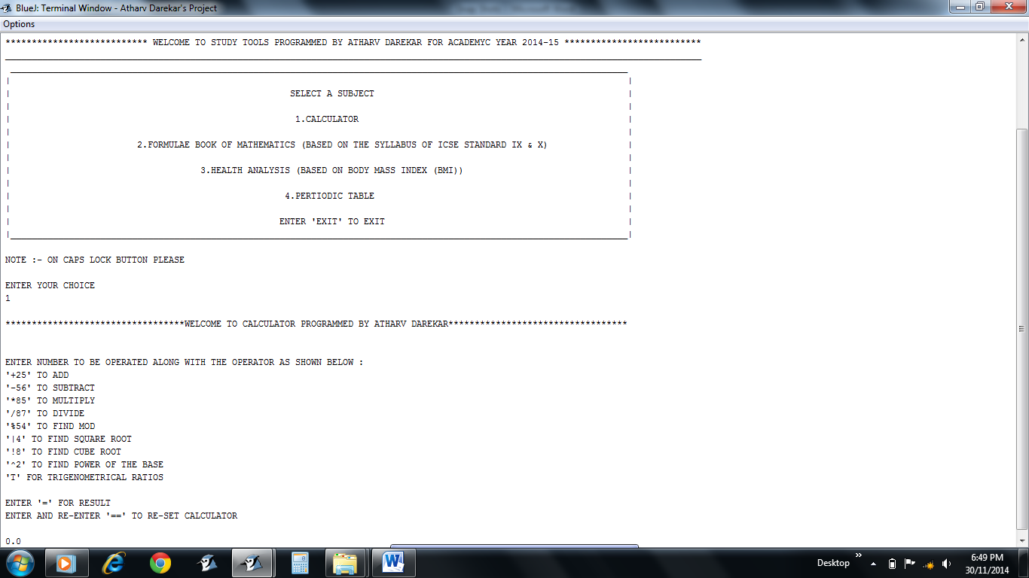

* Instructions given for giving input
* CALCULATOR showing 0.0 as initial value

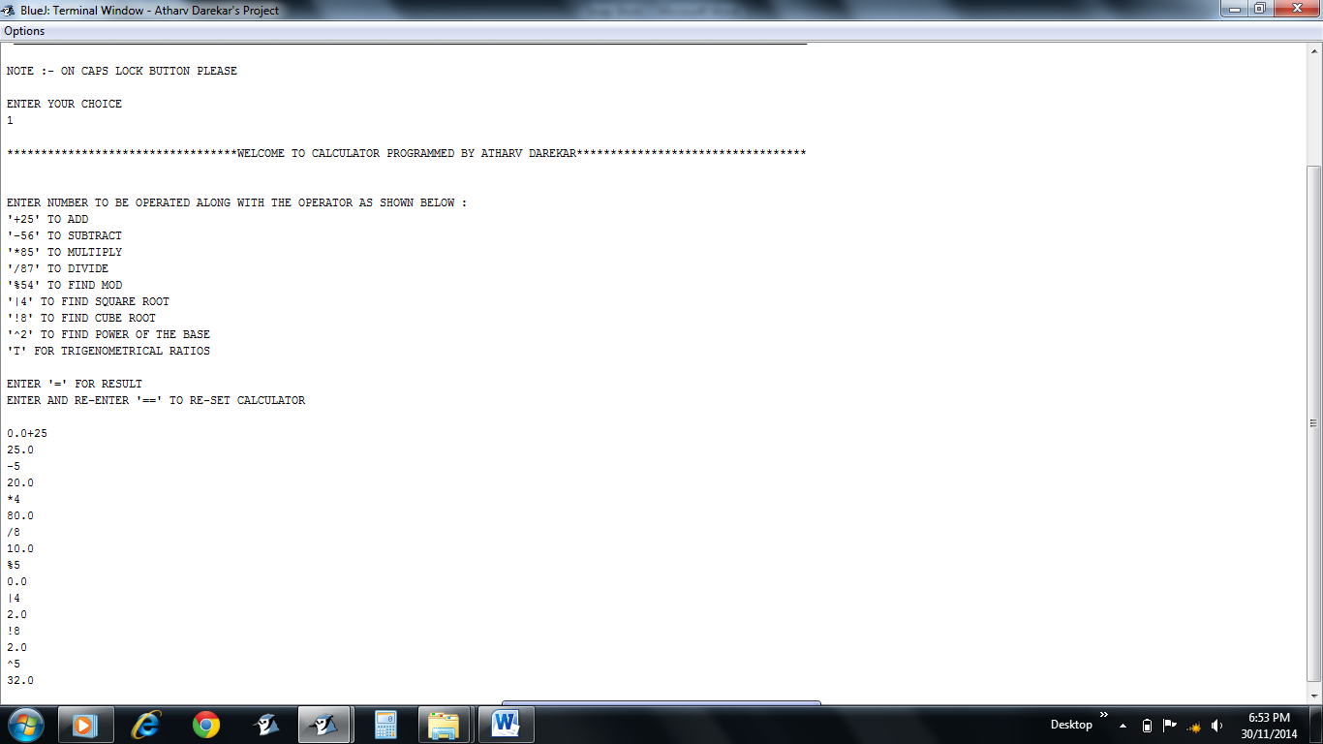

* Various operations done

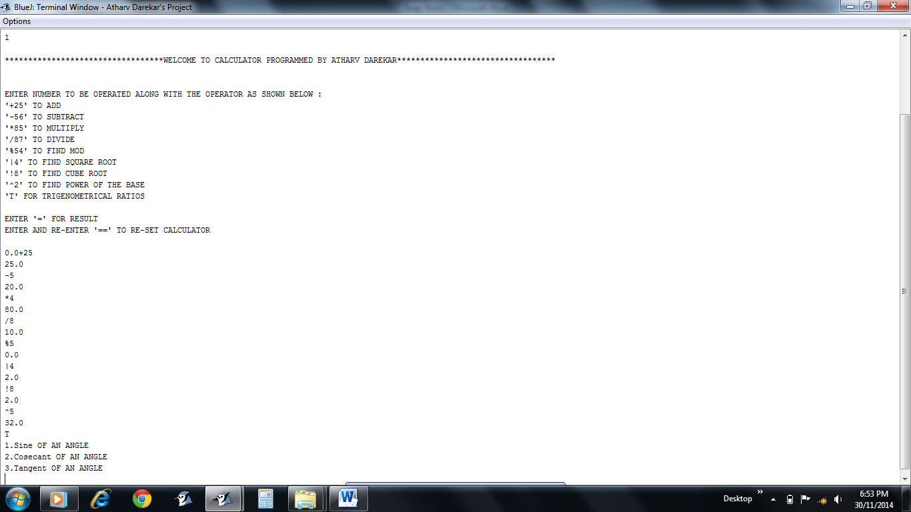

* T option for calculating trigonometric values

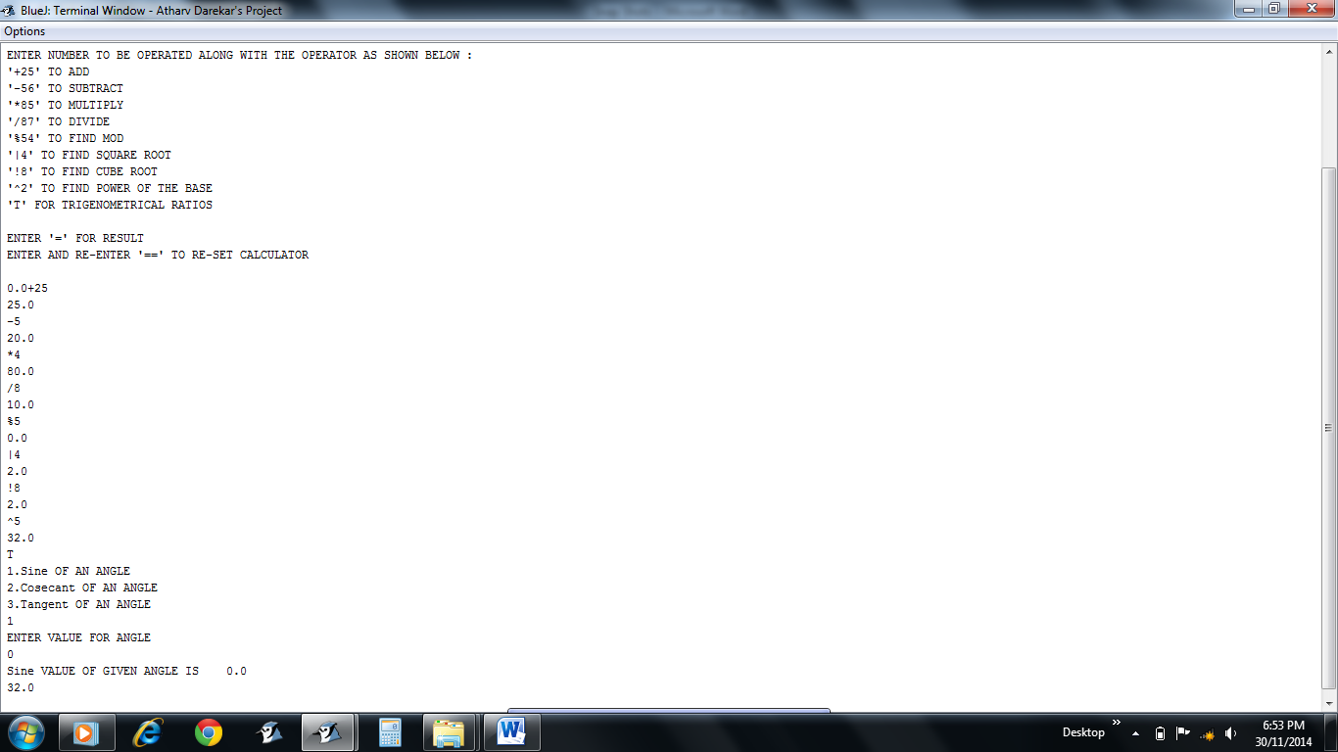

* Users choice according to requirement for calculating the trigonometric value

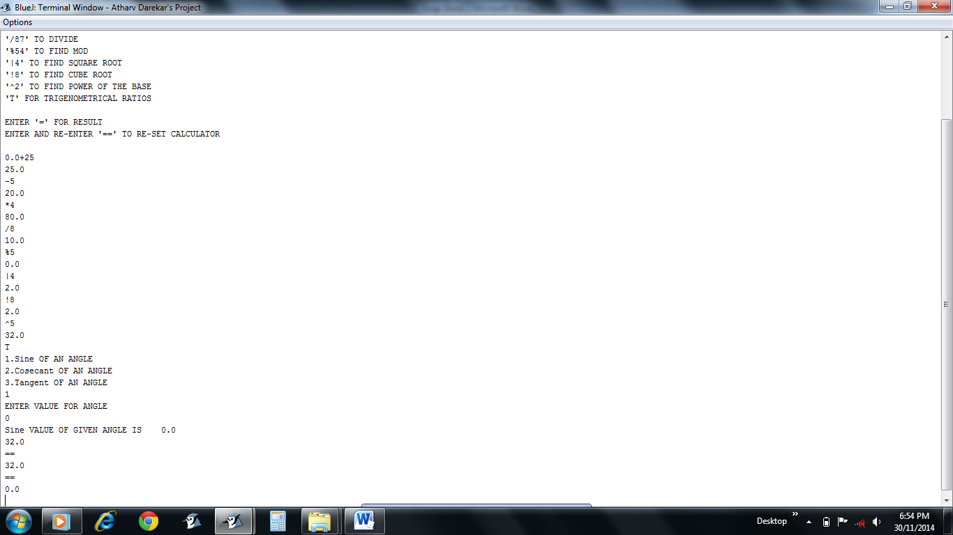

* Enter and Re-Enter “==” to reset the CALCULATOR

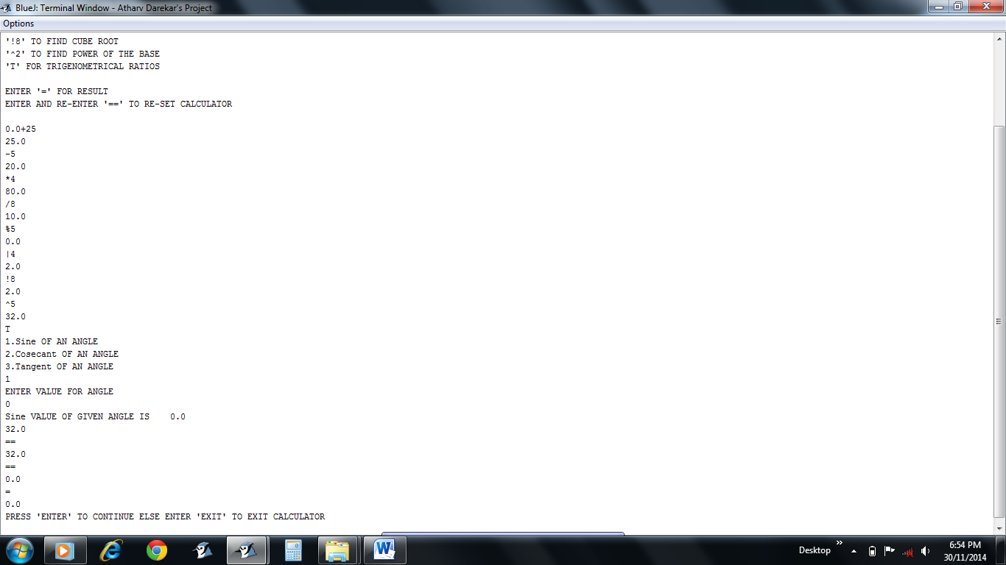

* “=” for final result as well as to quit the CALCULATOR

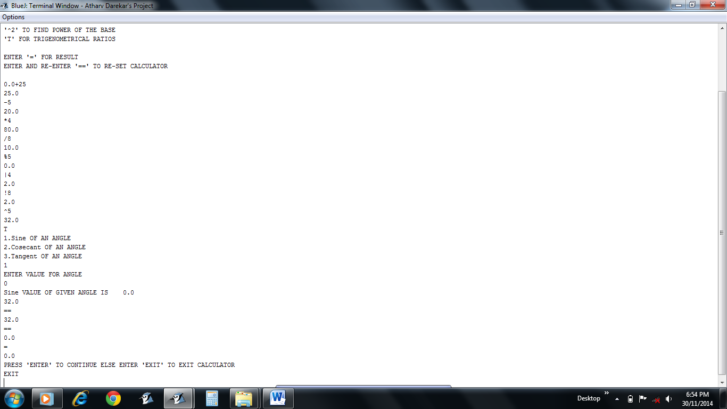

* “EXIT” command to exit the CALCULATOR
* Press ENTER to continue instead

**FORMULAE BOOK FOR MATHEMATICS**

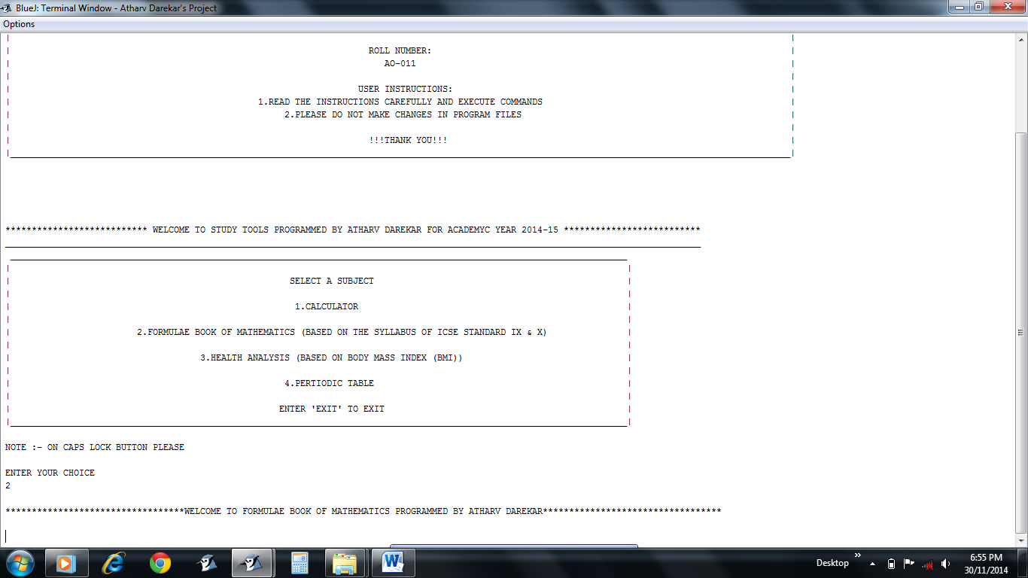

* 2 option for FORMULAE BOOK OF MATHEMATICS
* Greeting Message

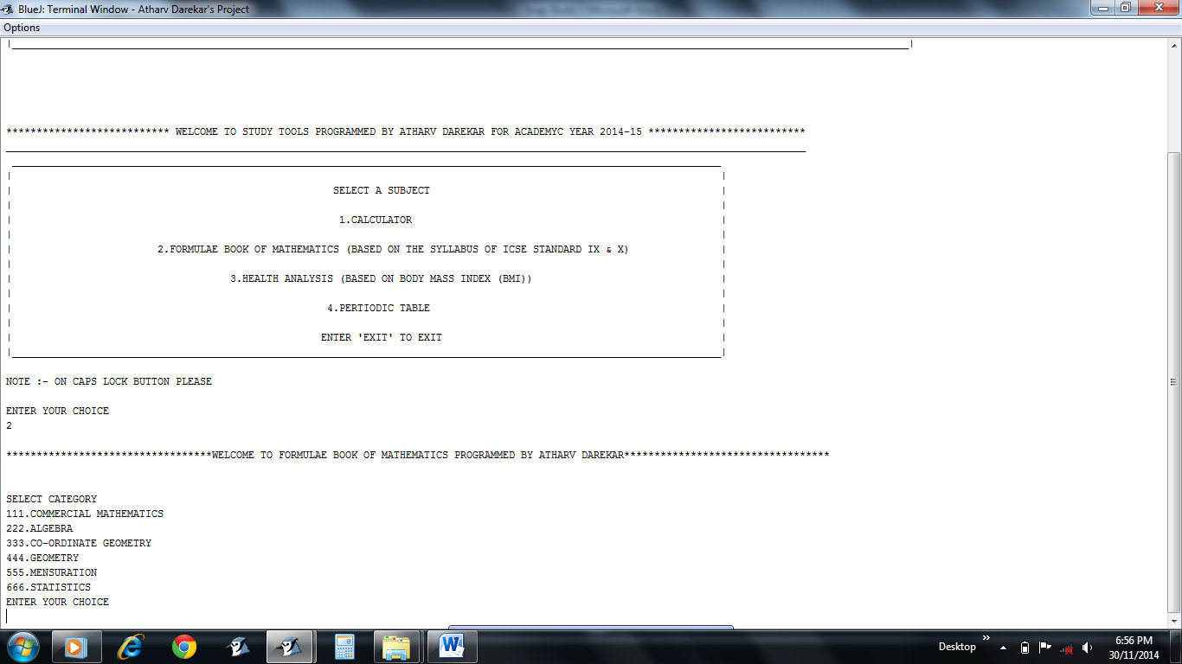

* Category to be selected by the user according to the requirement

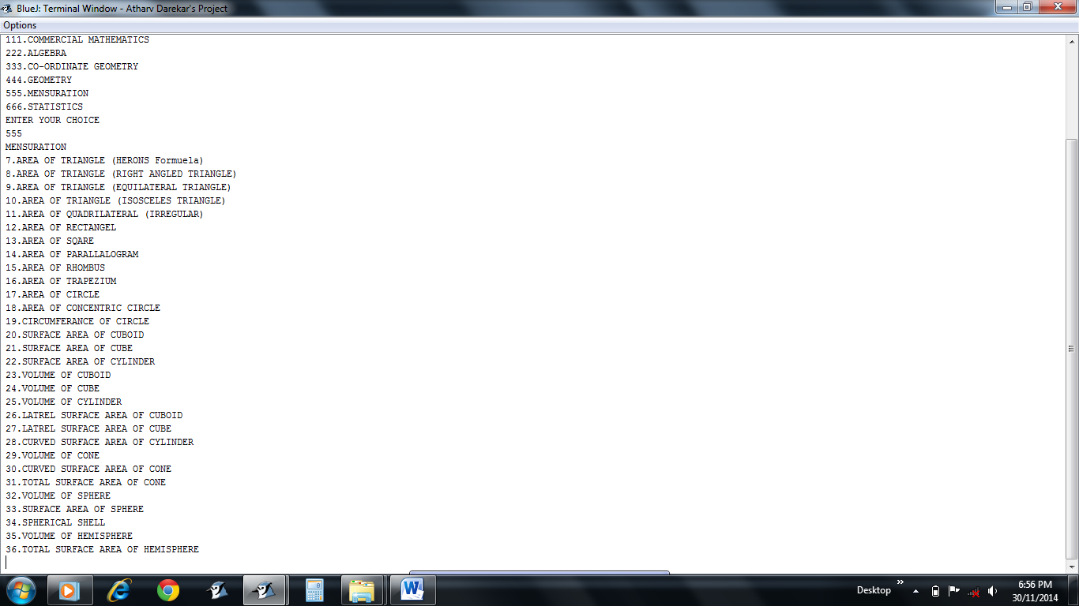

* 555 for MENSURATION category
* User has to choose the specific option as required

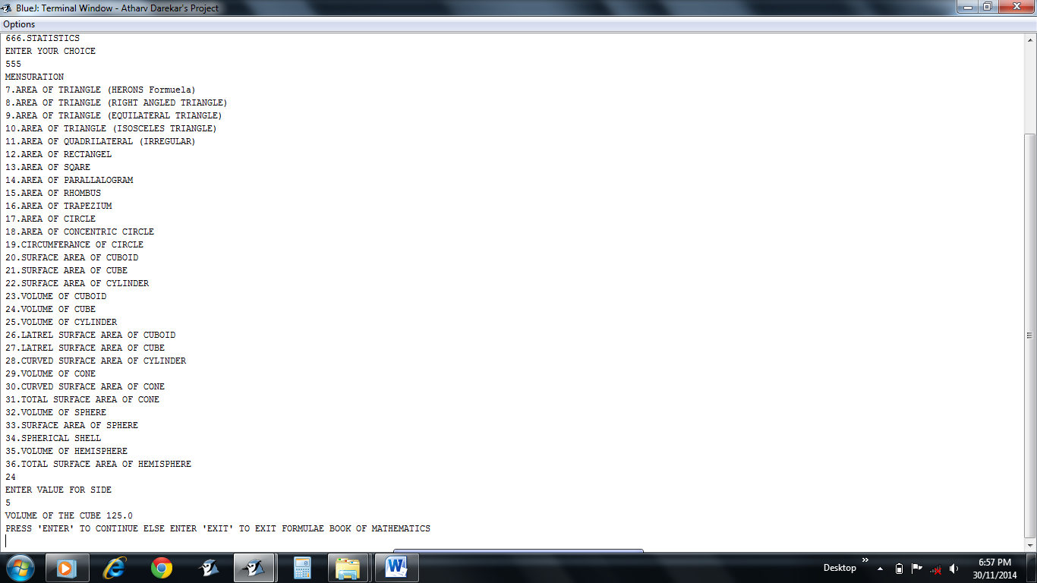

* 24 option to find VOLUME OF CUBE
* Result displayed

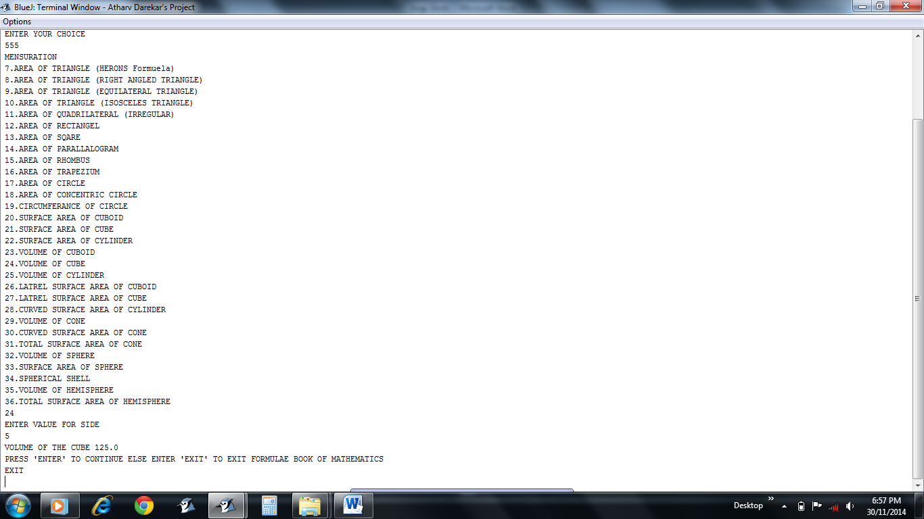

* “EXIT” command to quit FORMULAE BOOK FOR MATHEMATICS
* Press “ENTER” to continue instead

**HEALTH ANALYSIS**

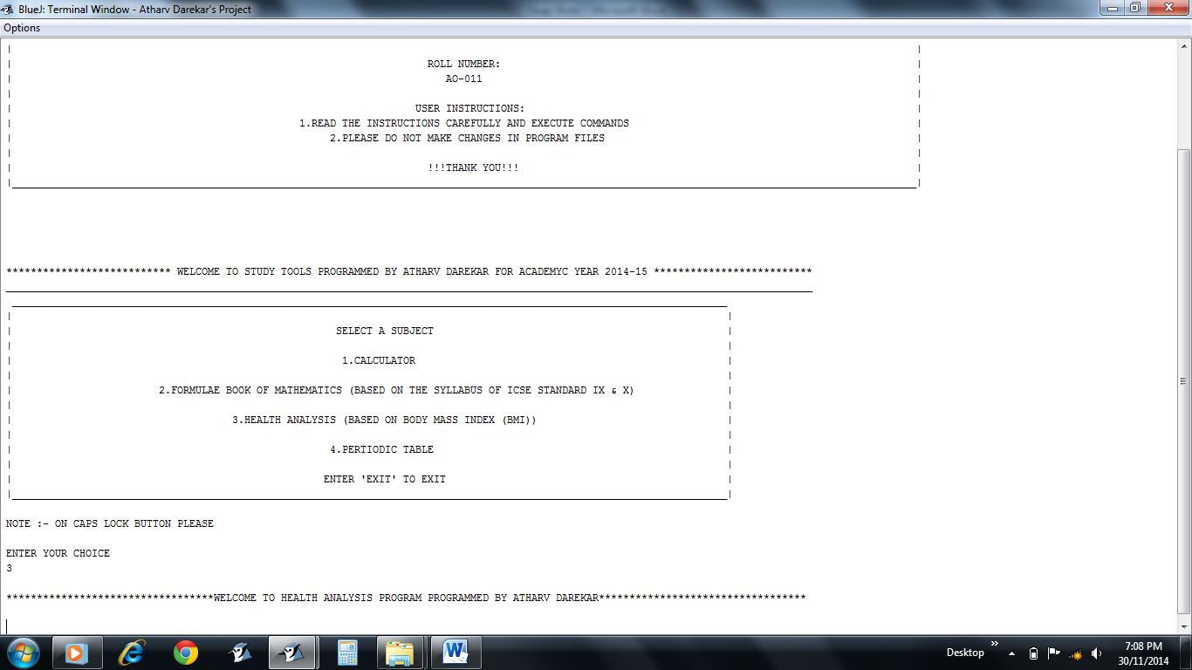

* 3 option for HEALTH ANALYSIS
* Greeting Message

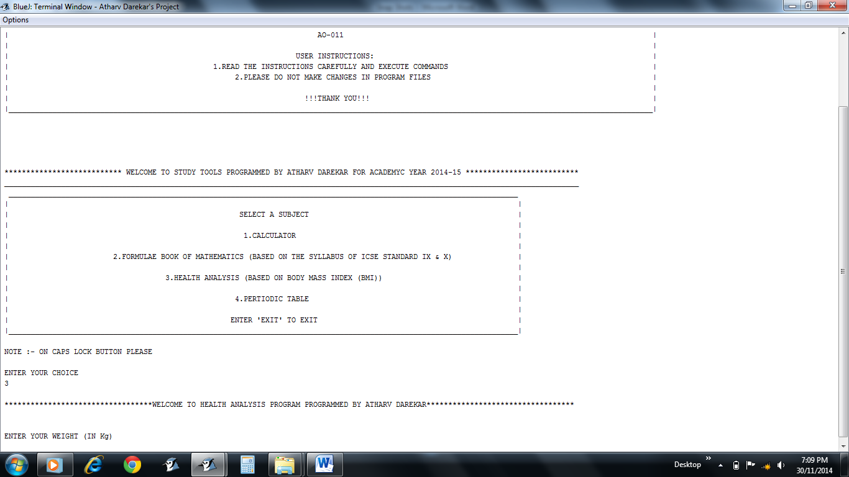

* Required input to calculate BMI

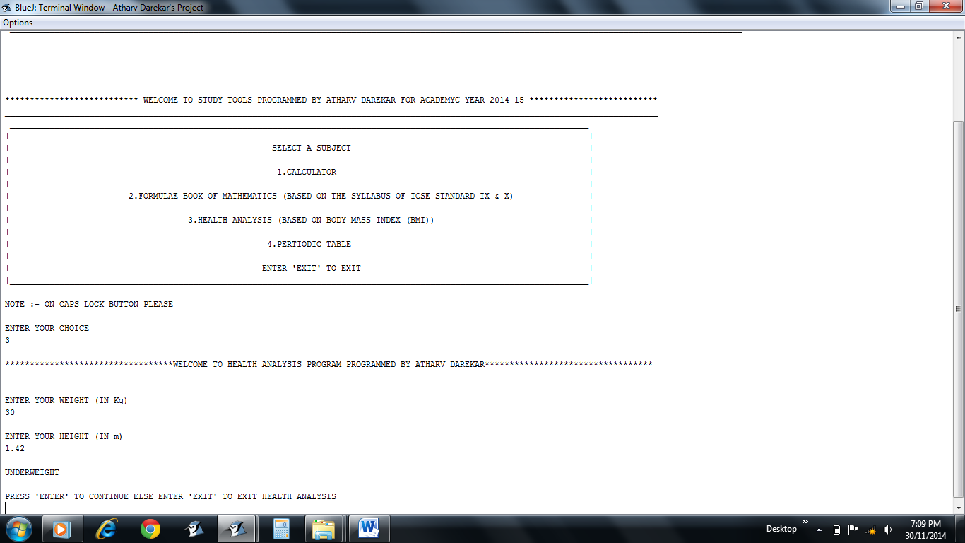

* Required input to calculate BMI
* Status as calculated by the Application

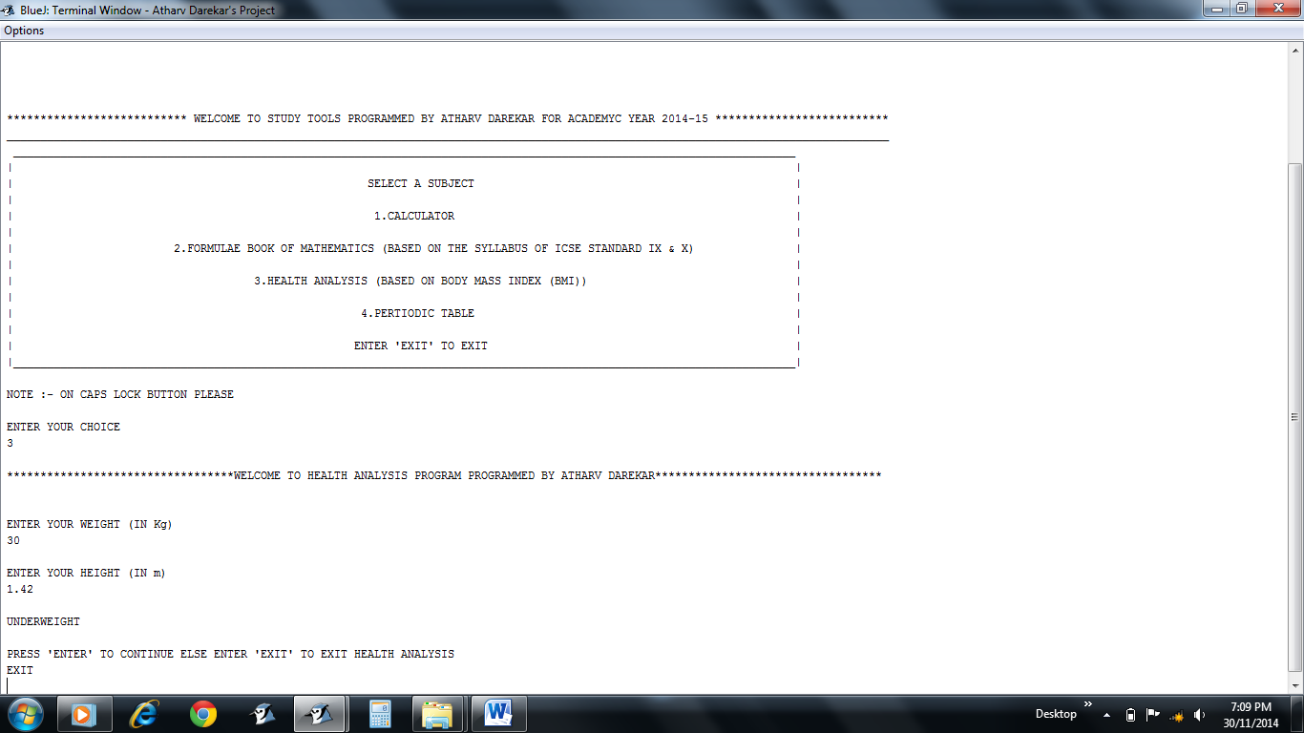

* “EXIT” command to quit HEALTH ANALYSIS
* Press “ENTER” to continue instead

**PERIODIC TABLE**

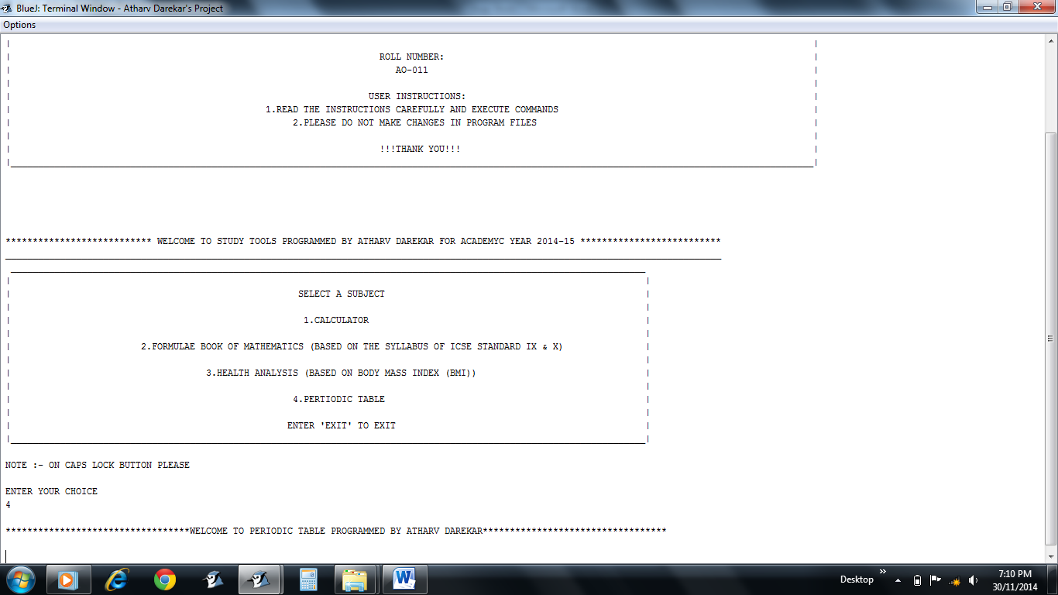

* 4 option for PERIODIC TABLE
* Greeting Message

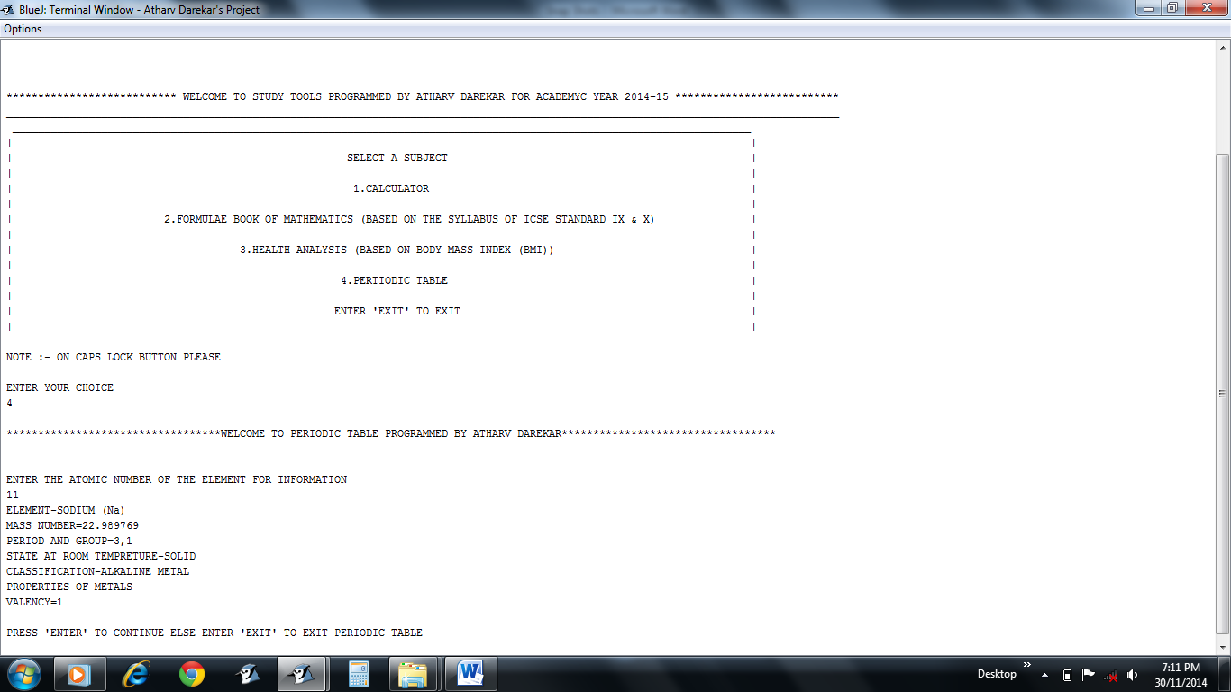

* According to input of the user the information of the respective element is displayed
* Message either to continue else to exit

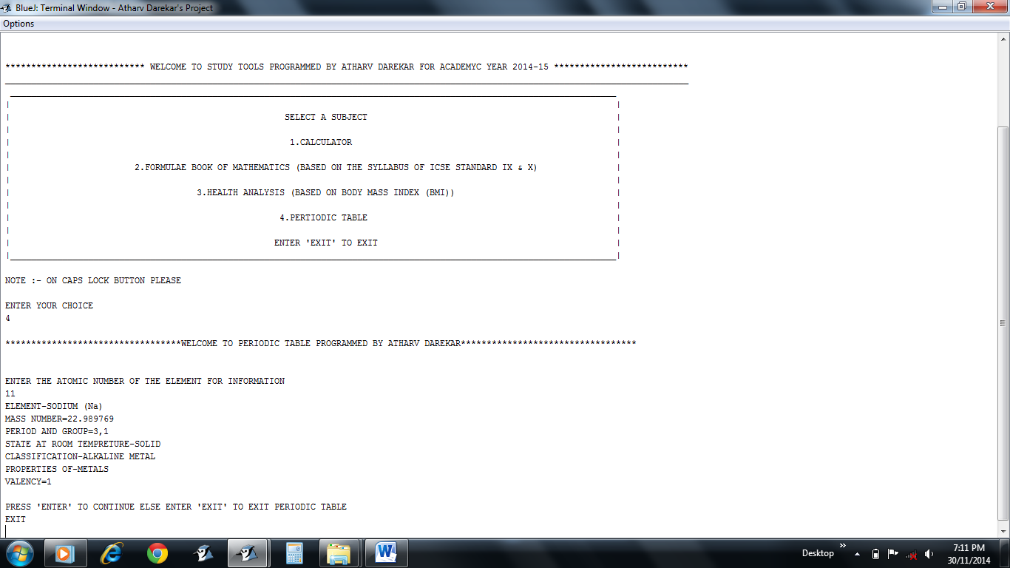

* “EXIT” command to quit PERIODIC TABLE
* Press “ENTER” to continue instead

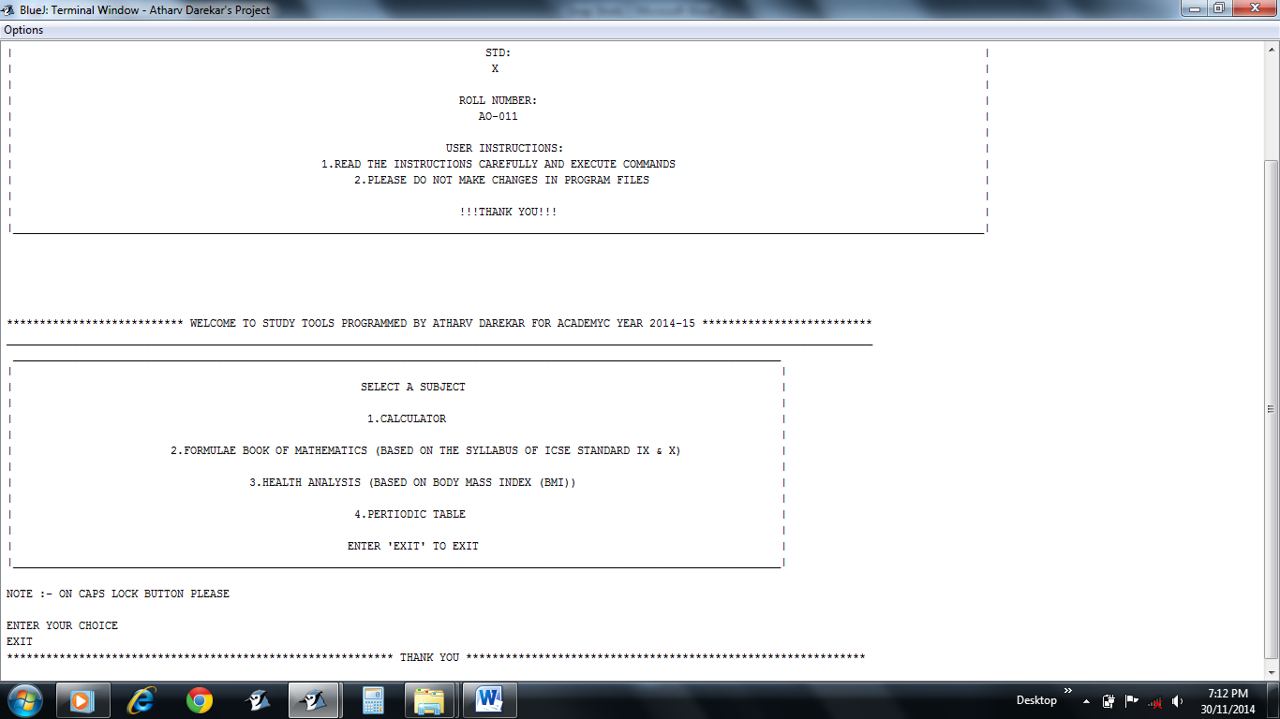

* “EXIT” command to quit MAIN MENU
* Choose a option to continue instead

**Demonstrating Run Time Error Fixation Feature of the “STUDY TOOLS” program**

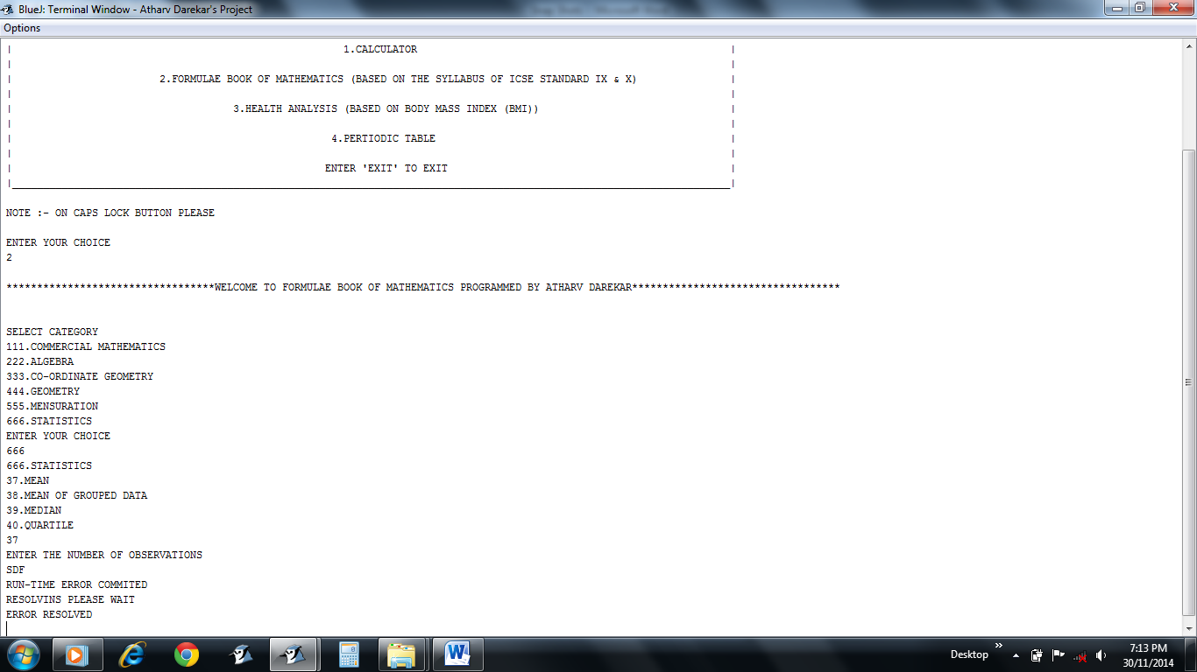

* Here the input was required as double but if user gives input as character or string generally the program terminates but here the error is resolved and user can resume with the work again